DE–694
11
DISTANCE EDUCATION
M.Sc. (Mathematics) DEGREE EXAMINATION,
DECEMBER 2010.
ALGEBRA
Time : Three hours Maximum : 100 marks
Answer any FIVE questions.
All questions carry equal marks.
- (a) If H and K are subgroups of G prove that HK is a subgroup of G if and only if HK = KH.
(b) If G is an abelian group of order o(G), and if p is a prime number, such that 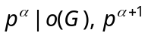 does not divide o(G) prove that G has a subgroup of order 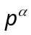.
- (a) Prove that the number elements conjugate to a in G os the index of the normalizer of a in G.
(b) Prove that the number of p-Sylow subgroups in G, for a given prime, is of the form 1 + 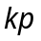.
- (a) Let G be a finite group and suppose that G is a subgroup of the finite group M. If M has a p-Sylow subgroup Q prove that G has a p-Sylow subgroup
P such that 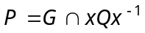 for some 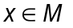.
(b) Discuss the number and nature of the 3-Sylow subgroups ans 5-Sylow subgroups of a group of order 3² . 5².
- (a) If R is a commutative ring with unit element and
M is an ideal of R, prove that M is a maximal of R if and only if R/M is a field.
(b) If G is the internal direct product of 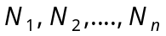 prove that for 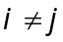, 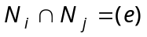, and if 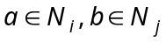 then ab = ba.
- (a) If R is a Euclidean ring and 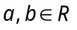 with 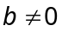 is not a unit in R prove that d(a)<d(ab).
(b) Prove that the ideal A = (a₀) is a maximal ideal of the Euclidean ring R if and only if a₀ is a prime element of R.
- (a) If V is n-dimensional over F and if 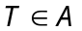(V) has all its characteristic roots in F prove that T satisfies a polynomial of degree n over F.
(b) If (V) is such that (vT, v) = 0 for all 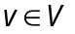, prove that T = 0.
- (a) If N is normal and AN = NA, then AN* = N*A.
(b) Prove that the element 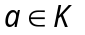 is algebraic over F if and only if F (a) is a finite extension of F.
- (a) Prove that a polynomial of degree n over a field can have at most n roots in any extension field.
(b) Prove that the fixed field of G is a subfield of K.
————————
DE–695
12
DISTANCE EDUCATION
M.Sc. (Mathematics) DEGREE EXAMINATION,
DECEMBER 2010.
REAL ANALYSIS
Time : Three hours Maximum : 100 marks
Answer any FIVE questions.
All questions carry equal marks.
- (a) State and prove Fixed-point theorem.
(b) Prove that compact subsets of metric spaces are closed . (10 + 10 = 20)
- State and prove the Bolzano-Weierstrass theorem.
- (a) State and prove chain rate.
(b) State and prove Generalised Mean-Value theorem.
(10 + 10 = 20)
- Assume 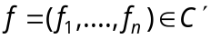 on an open set S in 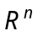, and let 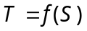. If the Jacobian determinate 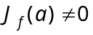 for some point a in S then prove that there are two open sets 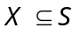 and 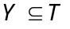 and a uniquely determined function g such that :
(a) 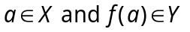
(b) 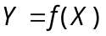
(c) is 1 – 1 on X.
(d) g is defined on Y, 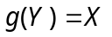 and 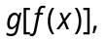 for every 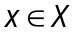.
(e) 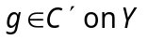.
- (a) Prove that if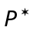 is a refinement of P, then 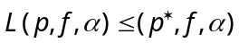 and 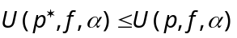.
(b) Show that 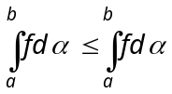.
(c) Show that 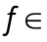 R 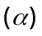 on [a,b] iff for every 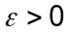 there exists a partition p such that 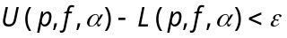 (6 + 6 + 8 = 20)
- Assume that each term of 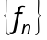 is a real-valued function having a finite derivative at each point of an open interval (a,b). Assume that for atleast one point 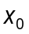 in (a,b) the sequence 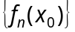 converges. Assume further that there exists a function g such that 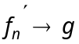uniformly on (a,b). Then such that :
(a) There exists a function f such that 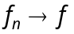 uniformly on (a,b).
(b) For every in (a,b) the derivative 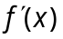 exists and equals 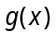.
- (a) Prove that the outer measure of an interval is its length.
(b) Prove that is 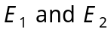 are measurable, so is 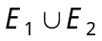. (10 + 10 = 20)
- State and prove monotone convergence theorem.
————————
DE–696
13
DISTANCE EDUCATION
M.Sc. (Mathematics) DEGREE EXAMINATION,
DECEMBER 2010.
DIFFERENTIAL EQUATIONS AND NUMERICAL METHODS
Time : Three hours Maximum : 100 marks
Answer any FIVE questions.
Each question carries 20 marks.
- (a) State and prove the existence theorem.
(b) Let be any solution of
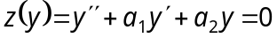 on an interval I containing a point 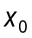. Then prove that for all in 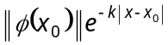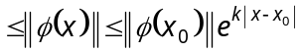 whose 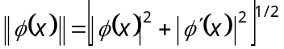, 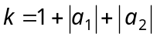.
(10 + 10 = 20)
- (a) Prove that the two solutions 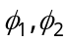 of 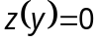 are linearly independent on an interval I if, and only if, 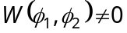 for all x in I.
(b) Solve the degendre equation. (10 + 10 = 20)
- Find the general integrals of the linear partial differential equations
(a)
(b) .
(10 + 10 = 20)
- (a) Prove that 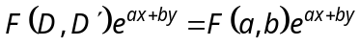.
(b) Find a particular integral of the equation 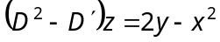.
(c) Find a particular integral of the equation 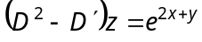. (8 + 6 + 6 = 20)
- (a) Obtain a linear polynomial approximation to the function 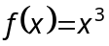 on the interval 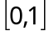 using the least square approximation with 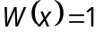.
(b) For the solution of the system of equations 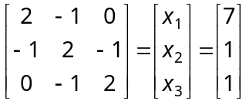 set of the 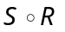 method. Find the relaxation factor and the rate of convergence. (10 + 10 = 20)
- (a) Consider the system of equations
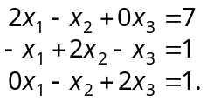
Use the Gauss Seidal iterative method and perform three iterations.
(b) Obtain the Chebyshev polynomial approximation of second degree to the function on .
(10 + 10 = 20)
- (a) The following table of values is given
x : | -1 | 1 | 2 | 3 | 4 | 5 | 7
f(x) : | 1 | 1 | 16 | 81 | 256 | 625 | 2401
Using the formula 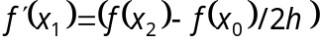 and the Richardson extrapolation, find 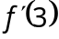.
(b) Find the approximate value of 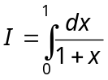. using
(i) Trapezoidal rule
(ii) Simpson’s rule. (10 + 10 = 20)
- (a) Explain Euler’s method and solve the initial value problem
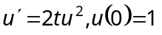 with 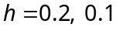 and 0.05 on the interval .
(b) Use the Numerov method to solve the initial value problem 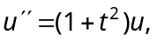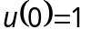,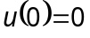, 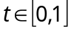 with 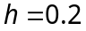. (10 + 10 = 20)

————————
DE–697
14
DISTANCE EDUCATION
M.Sc. (Mathematics) DEGREE EXAMINATION,
DECEMBER 2010.
OPERATIONS RESEARCH
Time : Three hours Maximum : 100 marks
Answer any FIVE questions.
(5 × 20 = 100)
- (a) Solve the following Linear Programming Problem graphically :
Maximize : 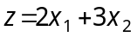
Subject to : 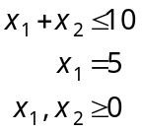
(b) Solve by Simplex method :
Maximize : 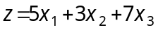
Subject to : 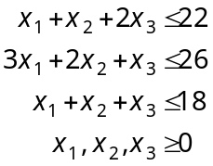
- (a) Write the dual of the linear programming problem.
Maximize : 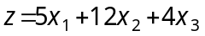
Subject to : 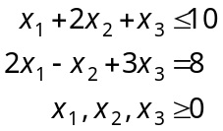
(b) Solve the linear programming problem using dynamic programming technique.
Maximize : 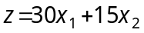
Subject to : 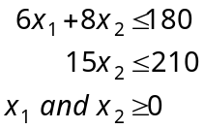
- (a) Consider the following cost matrix and determine the best order size using the minimax criterion.
 |  |  | Demand (Dj)
 |  | 50 | 100 | 150 | 200 | 250
 | 75 | 50 | 125 | 375 | 375 | 125
Order size 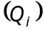 | 150 | 40 | 500 | 100 | 250 | 500
 | 225 | 750 | 550 | 250 | 750 | 125
 | 300 | 500 | 40 | 500 | 400 | 540
(b) Determine the Saddle-Point solution the Payoffs
are :
 |  | B
 | 8 | 6 | 2 | 8
A | 8 | 9 | 4 | 5
 | 7 | 5 | 3 | 5
- (a) Obtain Wilson’s economic lot size formula.
(b) A company has a steady demand of a product of 40 items per month. The purchase cost is Rs. 6 per item and cost of ordering and procuring the material is Rs. 15 per occasion. If stock holding cost is 20% per annum, how frequency should the company replenish the stock?
- (a) The activities involved in the Alpha Garment Manufacturing Company are listed with their time estimates as in the following table.
Activity | Description | Immediate predecessors | Duration days
A | Forecast sales volume | - | 10
B | Study competitive market | - | 7
C | Design item and Facilities | A | 5
D | Prepare production plan | C | 3
E | Estimate cost of production | D | 2
F | Set Sales Price | B, E | 1
G | Prepare budget | F | 14
Draw the network for the given activities and carry out the critical path calculations.
(b) Compute the total and free stocks for the critical and non-critical activities in the following network.
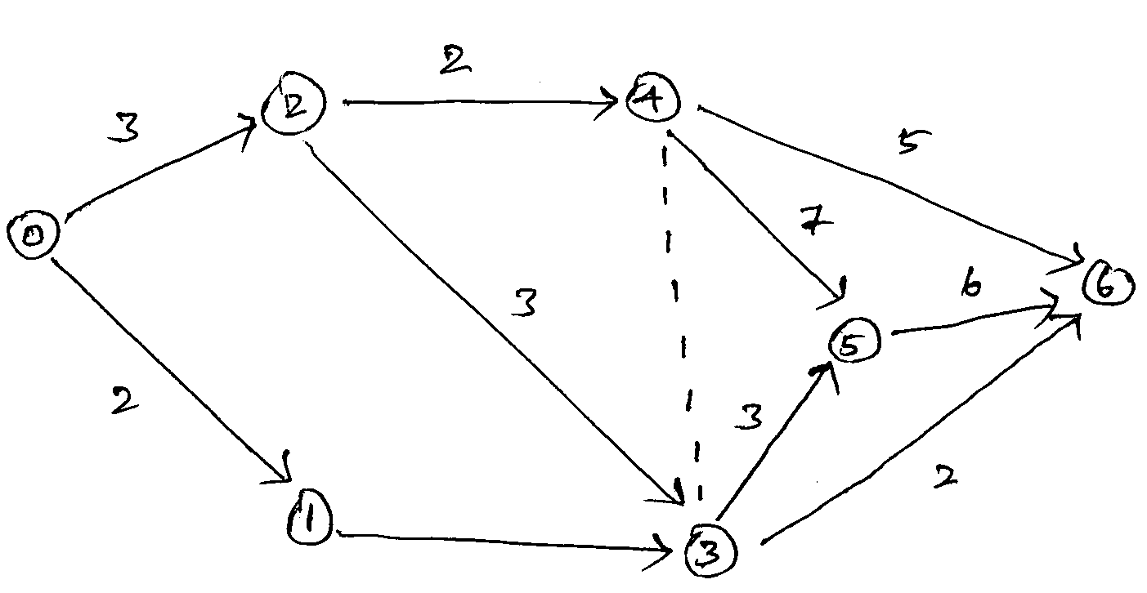
- (a) Given the following information :
Activity : | 0-1 | 1-2 | 1-3 | 2-4 | 2-5 | 3-4 | 3-6 | 4-7 | 5-7 | 6-7
Duration : | 2 | 8 | 10 | 6 | 3 | 3 | 7 | 5 | 2 | 8
(i) Draw the arrow diagram
(ii) Identify critical path
(iii) Find the total project duration.
(b) Find the critical path for the following project :
Activity | Estimated times | Activity | Estimated times
(i, j) | (a, b, m) | (i, j) | (a, b, m)
(0,1) | (1, 3, 2) | (3, 5) | (1, 7, 2.5)
(0, 2) | (2,8,2) | (3,6) | (1,3,2)
(1, 3) | (1, 3, 2) | (4, 5) | (6, 8, 7)
(2,3) | (1, 11, 15) | (4, 6) | (3, 11, 4)
(2,4) | (0.5, 7.5,1) | (5, 6) | (4, 8,6)
- (a) The annual demand for a component is 7,200 units. The carrying cost is Rs. 500 /unit / year, the ordering cost is Rs. 1,500 per order and the Shortage cost is Rs. 2,000/unit/year. Find the optimal values of economic order quantity, maximum inventory, maximum shortage quantity, cycle 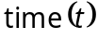, inventory period 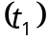 and shortage period 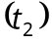.
(b) A company wants to determine the economic order size of each of the three boughtout item which are stocked in its stores. The detail of the items are presented in the table. The maximum space available is 500 square meter. Find the economic order size of each of the items subject to the space constraint.
 | 1 | 2 | 3
Demand (ton) | 1000 | 1500 | 750
Ordering cost / order (Rs.) | 500 | 700 | 300
Carrying cost / ton /year (Rs.) | 50 | 80 | 100
Space requirement / ton (sq. mt) | 2 | 01 | 03
- (a) Explain the Queueing Model.
(M/M/C) : (GD //).
(b) Arrival rate of customers at a banking counter follows Poisson distribution with a mean of 45 per hour. The service rate of the counter clerk also follows. Poisson distribution with a mean of 60 per hour.
(i) What is the probability of having 0 customer in the system 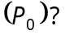
(ii) What is the probability of having 5 customers in the system 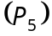?
(iii) Find 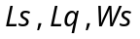 and 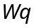.
——————
15
DE–698
DISTANCE EDUCATION
M.Sc. (Mathematics) DEGREE EXAMINATION,
DECEMBER 2010.
MATHEMATICAL STATISTICS
Time : Three hours Maximum : 100 marks
Answer any FIVE questions.
(5 × 20 = 100)
- (a) If the joint probability density function of X and Y is
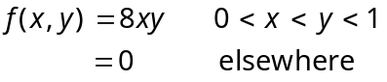
Find the conditional mean and conditional variance of Y given X = x.
(b) Define Beta distribution. Find its mean and variance.
- (a) Define a Poisson variate and find its moment generating function. Prove that the sum of independent Poisson variates is also a Poisson variate.
(b) Prove that if X and Y have a bivariate normal distribution with parameters 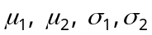 and then X and Y are independent if and only if 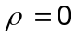.
- (a) Derive ‘t’ distribution.
(b) State and prove central limit theorem.
- (a) State and prove Rao-Cramer inequality.
(b) If 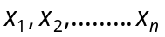 is a random sample from a population with p.d.f.
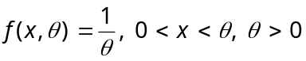.
Find the maximum likelihood estimator for .
- (a) Obtain 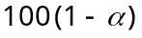% confidence limits for large samples for the parameter of the Poisson distribution.
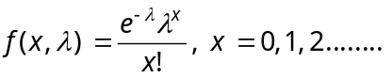
(b) State and prove Neymann Pearson lemma.
- (a) Of a sample of 500 pieces of pipes 30 are defective. Test the hypothesis that only 2% are defective at 5% level of significance.
(b) Find the critical region of the likelihood ratio test to test 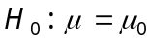 against 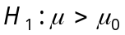 on the basis of random sample of size n from a normal distribution with known variance 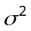.
- (a) Show that
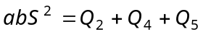
where 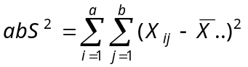
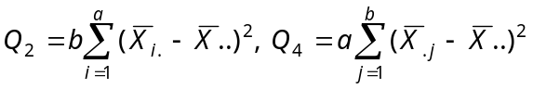 and
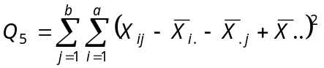
where 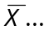 is mean of the ab observations 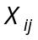, 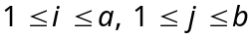 and 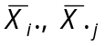 are row and column means respectively.
(b) Carry out ANOVA for
 | Sales man
Area | S₁ | S₂ | S₃ | S₄
A | 22 | 27 | 38 | 45
B | 28 | 32 | 40 | 38
C | 25 | 40 | 36 | 22
- (a) The tensile strength of 10 samples of 5 girders was measured and data is tabulated as follows :
Sample No : | 1 | 2 | 3 | 4 | 5 | 6 | 7 | 8 | 9 | 10
Total : | 32.0 | 32.6 | 29.0 | 32.0 | 34.6 | 26.4 | 33.2 | 28.8 | 32. | 29.0
Range : | 1.4 | 1.6 | 2.0 | 0.8 | 1.2 | 2.8 | 5.0 | 2.2 | 1.2 | 2.2
Calculate the values for the central line and the control limits of mean chart and then comment on the state of control
(Conversion factors :
)
(b) (i) Explain - control charts.
(ii) Explain 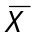-chart and R-chart and C-chart.
————————
DE–699
21
DISTANCE EDUCATION
M.Sc. (Maths) DEGREE EXAMINATION, DECEMBER 2010.
COMPLEX ANALYSIS
Time : Three hours Maximum : 100 marks
Answer any FIVE questions.
All questions carry equal marks.
- (a) Prove that any circle on the Riemann sphere corresponds to a circle or a straight line in the
z-plane.
(b) Prove that 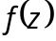 and 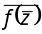 are simultaneously analytic.
- (a) State and prove Abel’s limit theorem.
(b) Discuss the mapping 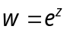.
- (a) If the function is analytic on the rectangle R, prove that 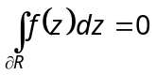.
(b) Compute 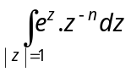.
- (a) State and prove Schwarz lemma.
(b) Show that a function which in analytic and bounded in the whole plane must reduce to a constant. Using this result, prove the fundamental theorem on algebra.
- (a) State and prove Rouche’s theorem.
(b) Using Rouche’s theorem, show that the equation 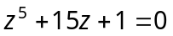 has one root in the disc 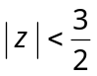 and four roots in the annulus 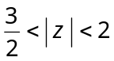.
- (a) Prove that 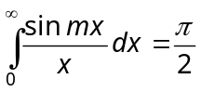.
(b) State and prove Hadamard’s factorization theorem.
- (a) Show that any two bases of same module are connected by a unimodular transformation.
(b) Show that
(i) an elliptic function without poles is a constant
(ii) the sum of residues of an elliptic function is zero.
- (a) Derive the Weierstrass 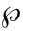-function.
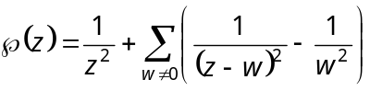.
(b) With usual notations, derive
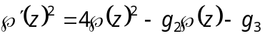.
—————————
DE–700
22
DISTANCE EDUCATION
M.Sc. (Maths) DEGREE EXAMINATION, DECEMBER 2010.
TOPOLOGY AND FUNCTIONAL ANALYSIS
Time : Three hours Maximum : 100 marks
Answer any FIVE questions.
All questions carry equal marks.
      - (a) Let X be a topological space, prove that
(i) any intersection of closed sets in X in closed and
(ii) any finite union of closed sets in X in closed.
(b) Let 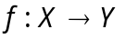 be a mapping of one topological space into another. Show that the following are equivalent.
(i) f is continuous
(ii) 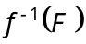 is closed in X whenever T is closed in Y.
(iii) 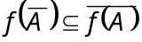 for every subset A of X.
(10 + 10 = 20)
2 (a) Prove that the product of any non-empty class of compact spaces is compact.
(b) Prove that any continuous mapping of a compact metric space into a metric space is uniformly continuous. (10 + 10 = 20)
  - (a) Prove that a metric space is compact if and only if it is complete and totally bounded.
(b) Prove that every compact Hausdroff space is normal. (12 + 8 = 20)
  - (a) State and prove Tietze extension theorem.
(b) Prove that any continuous image of connected space is connected. (12 + 8 = 20)
  - (a) State and prove closed graph theorem.
(b) Let M be a linear subspace of a normed linear space N, and let f be a functional defined on M. If 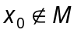 and if 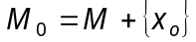 is a linear space spanned by
M and , then prove that f can be extended to a functional 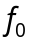 defined on 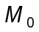 such that 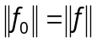.
(10 + 10 = 20)
  - (a) State and prove Schwarz inequality.
(b) If M is a closed linear subspace of a Hilbert space H, then prove that 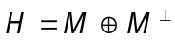. (10 + 10 = 20)
  - Let H be a Hilbert space and let 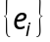 be an orthonormal set in H. Then prove that the following conditions are equivalent.
(a) is complete
(b) 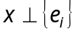 x = 0
(c) If x is an arbitrary vector in H, then 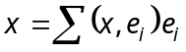
(d) If x is an arbitrary vector in H, then 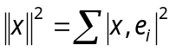.
  - (a) If T is an operator on H for which 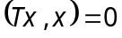 for all x, prove that 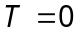.
(b) If 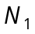 and 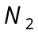 are normal operators on H with the property that either commutes with the adjoints of the other, then prove that 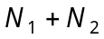 and 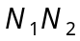 are normal.
(c) If P and Q are the projections on closed linear subspaces M and N of H, then prove that 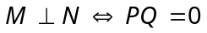. (6 + 6 + 8 = 20)
—————————
DE–701
23
DISTANCE EDUCATION
M.Sc. (Mathematics) DEGREE EXAMINATION,
DECEMBER 2010.
GRAPH THEORY
Time : Three hours Maximum : 100 marks
Answer any FIVE questions.
All questions carry equal marks.
  - (a) Show that if G has n vertices and m edges, then 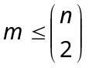. (b) If G is self complementary, then prove that 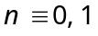. 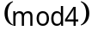. (c) Prove that a graph is bipartite if and only if, it contains no odd cycle. (10)
  - (a) Show that in a tree, any two vertices are joined by a unique path. (5)
(b) Prove that the following statements are equivalent for a graph with n vertices and 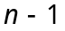 edges
(i) G is connected
(ii) G is a tree
(iii) G is acyclic. (5)
(c) State and prove Chvatal’s sufficient condition for a graph to be Hamiltonian. (10)
  - (a) Define connectivity K and edge connectivity 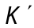. Give an example of a graph for each of the
following : (5)
(i) 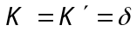
(ii) 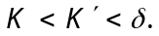
(b) Prove that every connected graph contains a spanning tree. (5)
(c) State and prove Kruskal’s algorithm for finding a minimum weight spanning tree of a weighed graph.
(10)
  - (a) Define and give example for each of the following :
(i) Independence number
(ii) Covering number 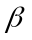
Also prove that 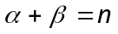. (10)
(b) State and prove Brook’s theorem. (10)
  - (a) If G is bipartite, then 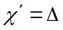. (5)
(b) If 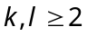 , then prove that (5)
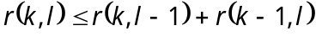.
(c) Define a 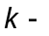critical graph and give one example. If G is k-critical, then prove that 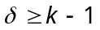. (10)
  - (a) Prove that every planar graph is 5-vertex colourable. (10)
(b) Show that the graph 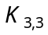 is nonplanar. (5)
(c) Show that all planar embeddings of a given connected planar graph have the same number of faces. (5)
  - (a) Find 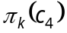. (5)
(b) If G is 2-edge connected, then show that G has a disconnected orientation. (5)
(c) Prove that 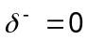 for a digraph with no directed cycle. (10)
  - (a) Prove that for any flow f and cut 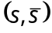in N, 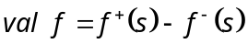. (5)
(b) Prove that for any flow f and any cut 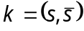 in N, val 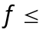 cap K. (5)
(c) Prove that a flow f in N is a maximum flow if and only if N contains no f-incrementing path. (10)
———————
DE–702
24
DISTANCE EDUCATION
M.Sc. (Maths) DEGREE EXAMINATION, DECEMBER 2010.
PROGRAMMING IN C/C++
Time : Three hours Maximum : 100 marks
Answer any FIVE questions.
All questions carry equal marks.
      - (a) Explain the various types in program development.
(10)
(b) What is object oriented programming? List out the important features of object oriented programming.
(10)
      - (a) Explain the following in ‘C’ with example.
(i) # include command (5)
(ii) Return () function. (5)
(b) Explain the different data types with example. (10)
  - (a) Explain any five input-output functions in C/C++ with example. (10)
(b) Given marks in five subject, write a program to print the total and average marks obtained by a student. (10)
  - (a) Explain how will you define and declare user defined functions. (10)
(b) Explain the scope of local and global variables with example. (10)
  - (a) Explain the syntax of the ‘switch’ command with example. (10)
(b) Using ‘for’ loop write a program to print the first ‘n’ numbers of the fibonacci series. 0, 1, 1, 2, 3, 5, … (10)
  - (a) Explain the following with example
(i) relational operators. (5)
(ii) logical operators. (5)
(b) Write a program to display the given names in alphabetical order. (10)
  - (a) Define structure and explain how will you structure variables. (10)
(b) (i) What are the advantages of using pointers? (3)
(ii) How will you declare and initialize pointer variables? (7)
  - (a) Explain any five file related functions. (10)
(b) Write a program that accepts your name and address and stores it in a file. (10)
———————
DE–703
25
DISTANCE EDUCATION
M.Sc. (Mathematics) DEGREE EXAMINATION,
DECEMBER 2010.
DISCRETE AND COMBINATORIAL MATHEMATICS
Time : Three hours Maximum : 100 marks
Answer any FIVE questions.
Each question carries 20 marks.
      - (a) Explain with example about the Ferrers graph of a partition.
(b) Show that the number of ways to put non-distinct objects into r-non-distinct cells is 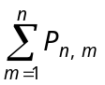.
      - (a) Solve the recurrence relation
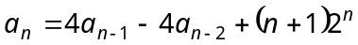.
(b) Use the method of generating function to solve the recurrence relation 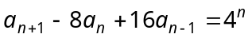 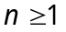 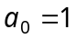, 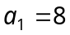.
  - (a) Find the number of integers between 1 and 250 both inclusive that are not divisible by any of the integers 2, 3, 5 and 7.
(b) How many solutions does the equation 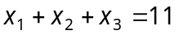 have, where 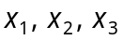 are
non-negative such that 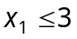, 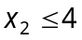 and 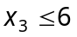? Use principle of Inclusion-exclusion.
  - (a) Prove that when repetition of n elements contained in a set is permitted in r-permutation is 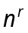.
(b) Show that the number of derangements of n symbols in 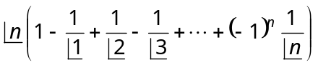 consequently, the probability that a given permutation of n symbols has no fixed points 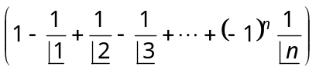.
  - (a) Find the cycle index of the permutation group 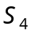.
(b) Show that 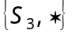 where 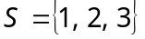 is a group under the operation of right composition of permutation.
  - (a) State and prove Burnside lemma.
(b) Show that the product of two odd permutation is even while the product of an even permutation and an odd permutations is odd. The inverse of a permutation has the same parity as that permutation.
  - (a) Show that with an example that the union of two sublattices not be a sublattice.
(b) In a Boolean algebra, prove that the following statements are equivalent
(i) 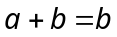
(ii) 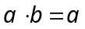
(iii) 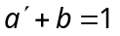
(iv) 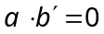.
  - (a) Maximise the function
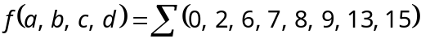
using Karnaugh map method.
(b) Explain the symbolic representation of switches.
———————

